Chapter 6
RESULTS
6.1 Snapshots
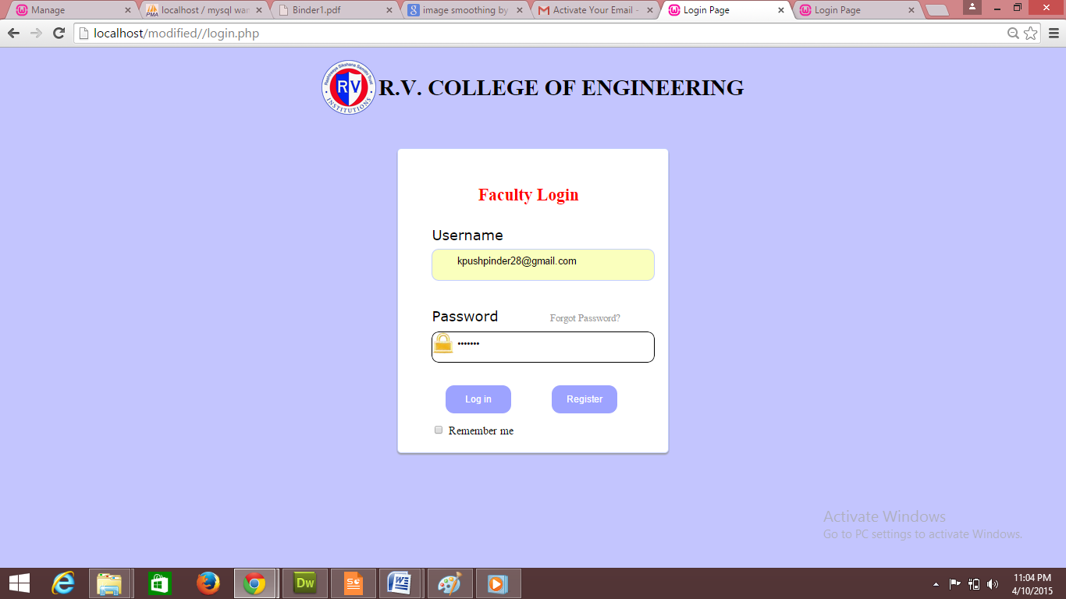
Fig 6.1 Snapshot of Login page

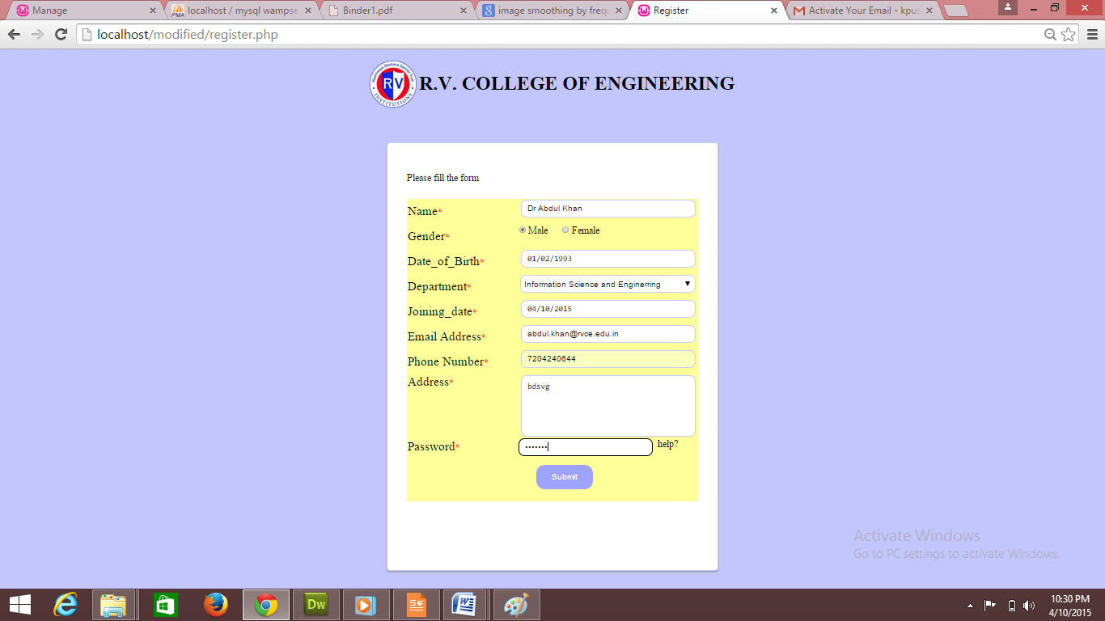
Fig 6.2 Snapshot of Registration page

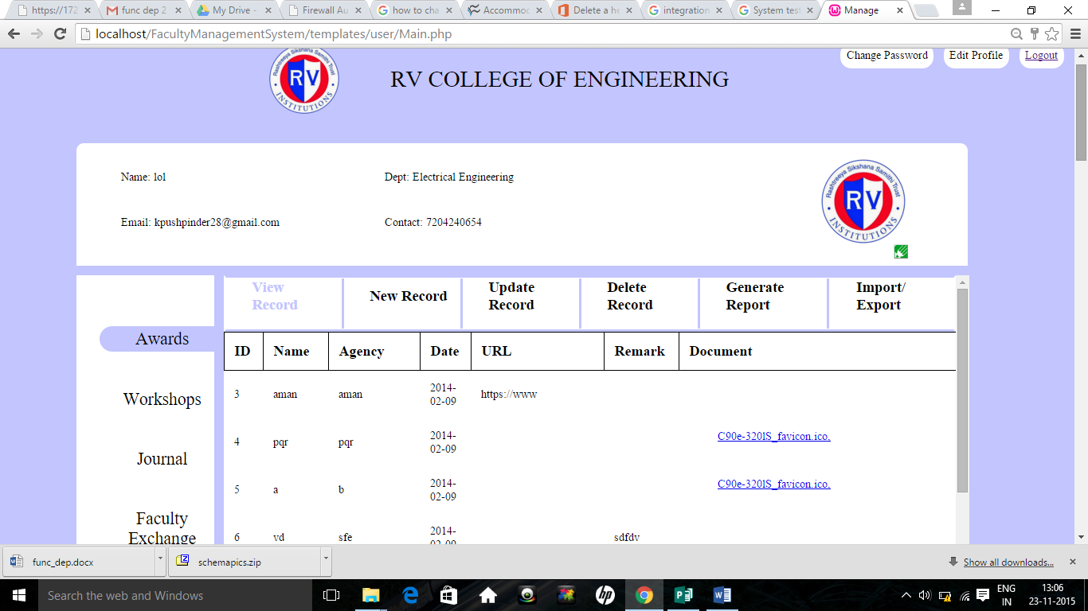
Fig 6.3 Snapshot of overview page

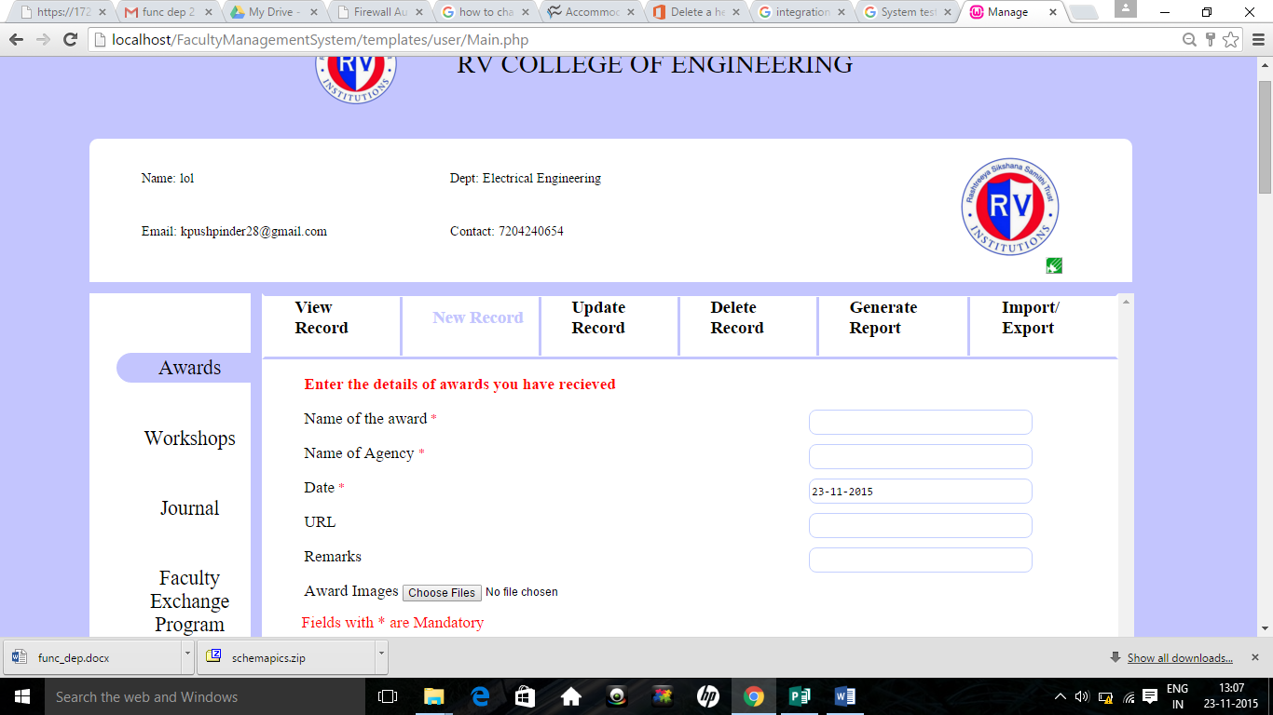
Fig 6.4 Snapshot of insertion page

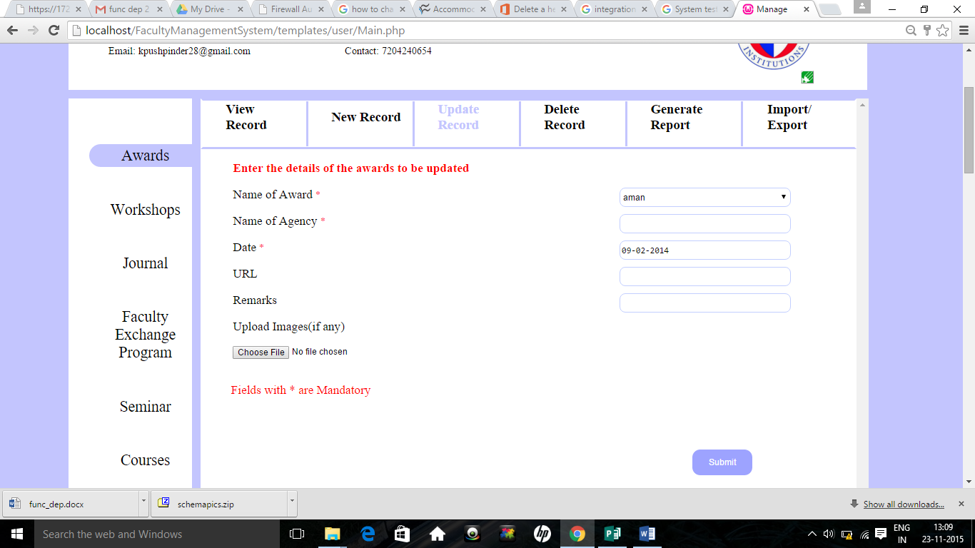
Fig 6.5 Snapshot of update page

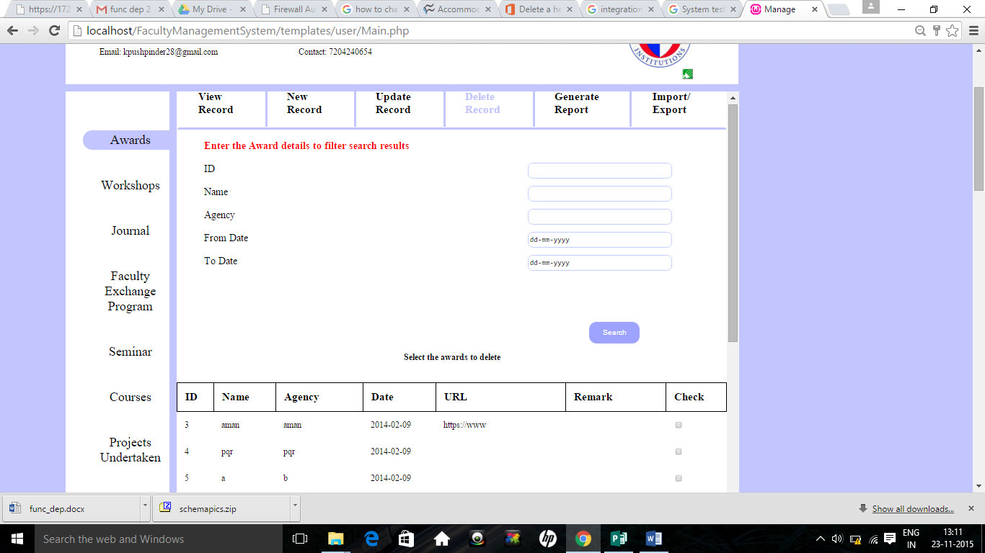
Fig 6.6 Snapshot of deletion page

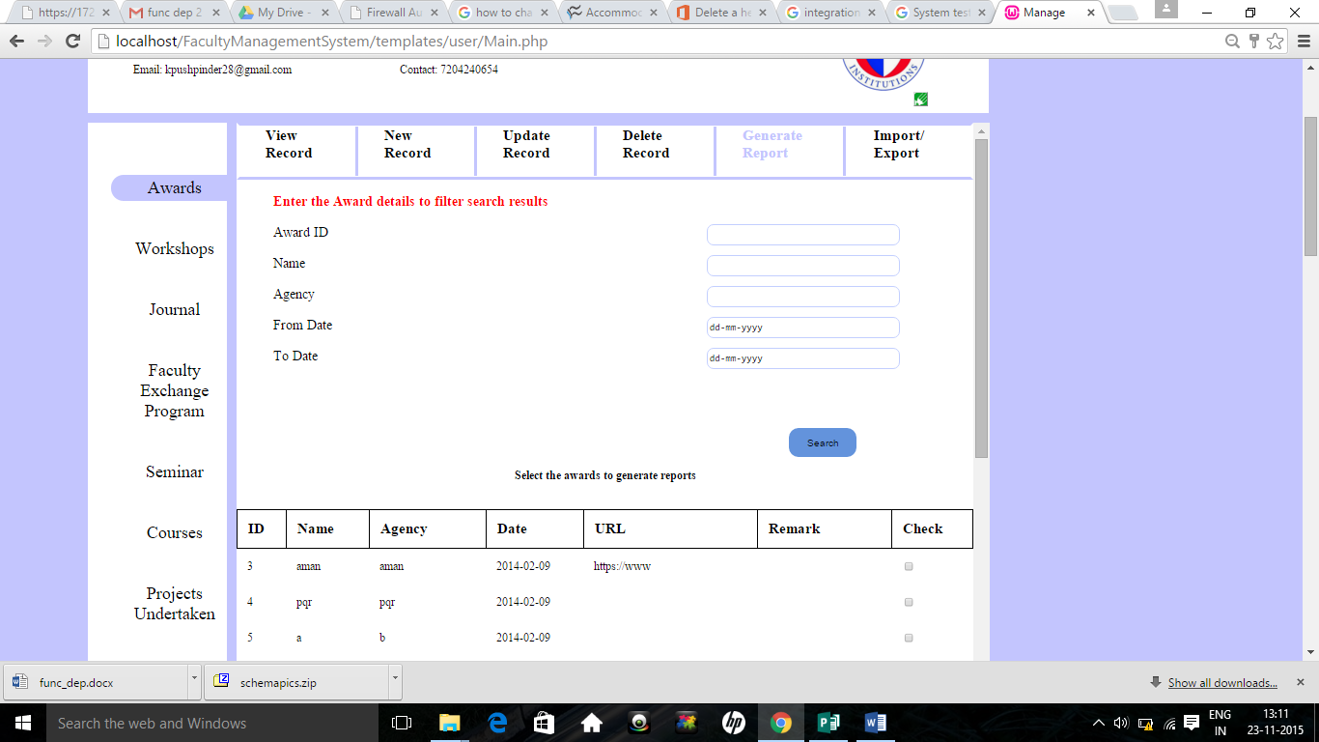
Fig 6.7 Snapshot of report generation page

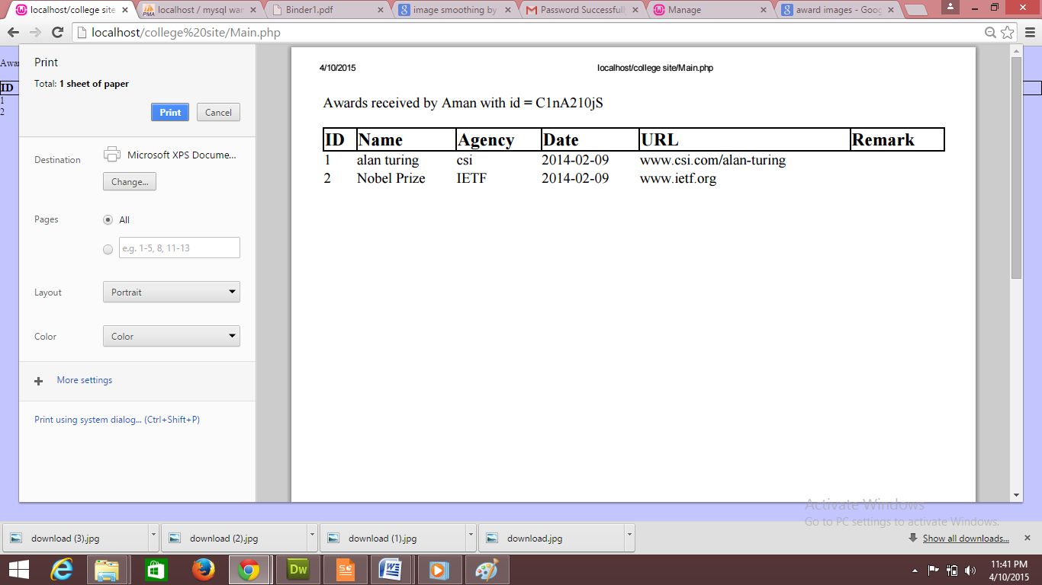
Fig 6.8 Snapshot of report generated

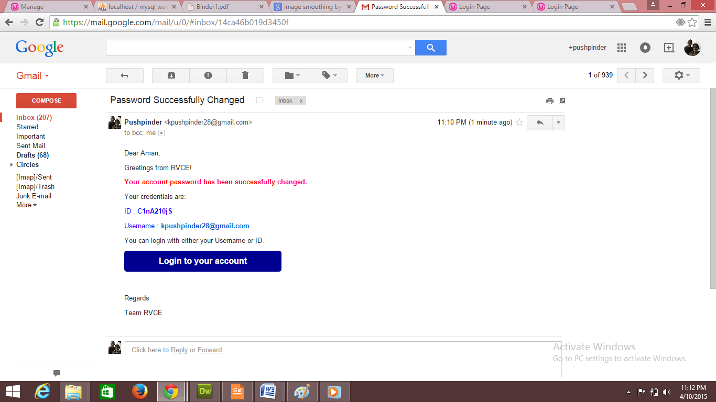

Fig 6.9 Snapshot of verification email

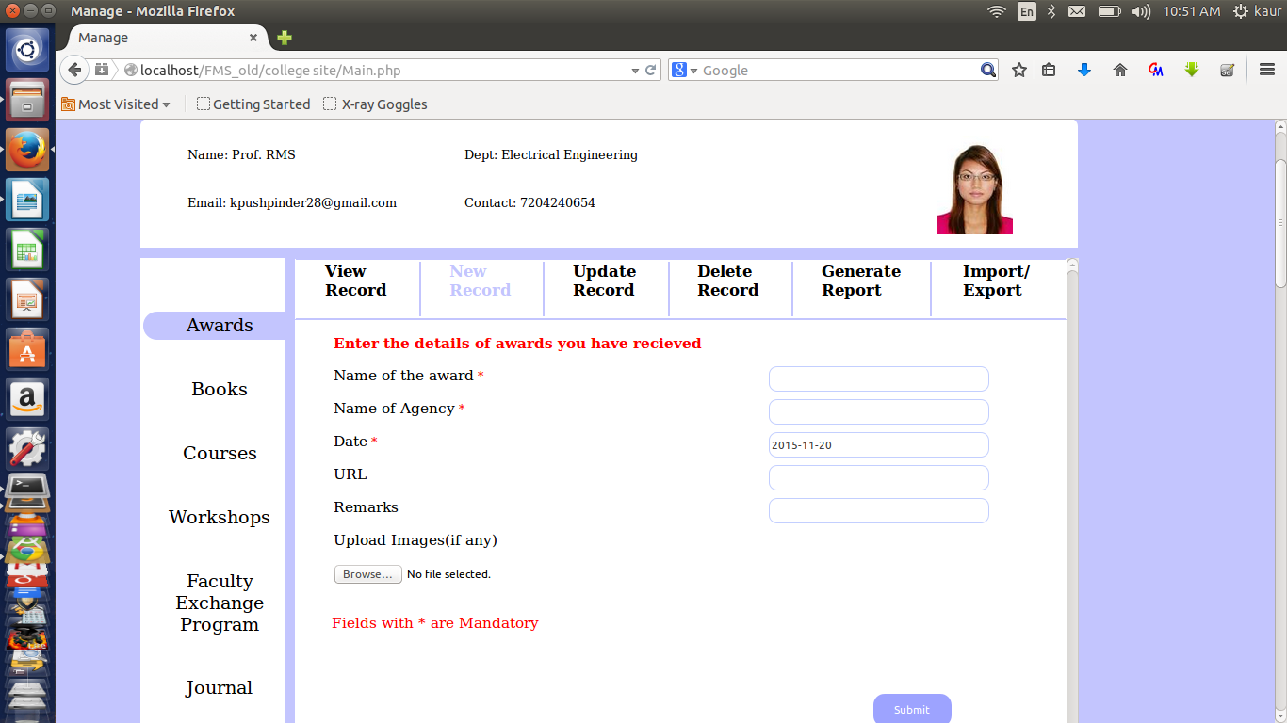
Fig 6.10 Snapshot of Intelligent System in action

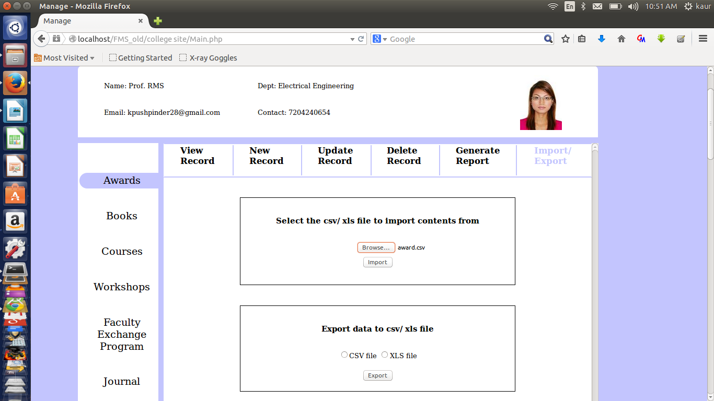

Fig 6.11 Import Export Snapshot

6.2 Advantages of the project
This project is built to provide the following advantages.
- The FMP is created to keep track of all faculty data.
- FMP module provides the facility of username and password for each faculty so that they can easily access or modify their info without taking help of administrator.
- The FMP is one place where the faculty manage all their data
- The FMP module provides the Faculty to view their various acheivments.
- Verification mail is sent to verify the user
- FMP module also provides report generations.
- FMP allows the person to update the data once it is entered

6.3 Limitations of the project
The project has its own limitations
- FMP does not provide the functionality to generate customized reports.
- FMP doesn’t allow the user to manage their college transactions and salary.
Chapter 7
CONCLUSION
The Faculty Management for R V College of Engineering focuses on reducing the human efforts for details of the faculties of the college. Thus FMS module gives customized results all the time, as by giving the pdf of the selected data. The FMS module is tested and re-tested to ensure its effectiveness and provide error free functionality to end user. The AR module hence assures saving of time in finding resources in a appropriate way.

7.1 Future Enhancement
The Faculty Management module can overcome the previously stated limitations by adding few extra features to it such as
- FMS will advance in a spam control for non authorized users.

References
[1] Elmasri and Navathe, Fundamentals of Database Systems, 5th edition, Addison-Wesley, 2007.
[2] Raghu Ramakrishnan and Johannes Gehrke, Database Management Systems, 3rd edition,
McGraw-Hill, 2003.
[3] Silberschatz, Korth and Sudharshan, Database System Concepts, 5th Edition, McGraw-Hill 2006.

[4] Eric T Freeman, Elizabeth Freeman, Elizabeth Robson, Head First HTML with CSS & XHTML, OReilly’
[5] C.J.Date, A.Kannan, S.Swamynatham, A Introduction to Database Systems, 8th edition,
Pearson Education, 2006.
[6] www.w3schools.com for online tutorials on PHP, HTML, CSS, MySQL.
[7] An Oracle White Paper in Enterprise Architecture December 2012,
An Oracle White Paper in Enterprise Architecture - Oracle Enterprise Architecture Framework: Information Architecture Domain, Version 2.0"
[8] Hans Admiraal, Pitfalls using UML in RUP
[9] Sparx Systems 2015, Sparx Systems Enterprise Architect 12 Reviewer’s Guide
[10] Mala Dutta, Kamal K Sethi and Ajay Khatri, Web Based Integrated Development Environment, IJITEE, ISSN: 2278-3078, Volume-3, Issue-10, March 2014
[11] Jennifer Niederst Robbins, Learning Web Design: A Beginner's Guide to HTML, CSS, Javscript, and Web Graphics, 2nd Edition, 2014

Appendix-A

LIST OF ACRONYMS

- FMS: Faculty Management System
- SRS: Software Requirement Specifications
- ER: Entity Relationship
- OS: Operating System
- RAM: Random Access Memory
- SQL: Structured Query Language
- PHP: Hypertext Preprocessor(Personal Home Page)
- RDBMS: Relational Database management system

Appendix-B
CODING

Coding For Login Page

<!DOCTYPE html>
<html>
<head>
<title>Admin Login</title>
<meta name="viewport" content="width=device-width, initial-scale=1.0">
<meta charset="utf-8">
<link href="event.css" rel="stylesheet" type="text/css">
</head>
<body>
<br >
<div align=center><font color="FF0000">
<?php
session_start();
$host="localhost"; // Host name
$username="root"; // Mysql username
$password=""; // Mysql password
$db_name="studentadmission"; // Database name
$tbl_name="student"; // Table name
$f_email_id="";
$f_mobile_number="";

$con=mysqli_connect("$host", "$username", "$password","$db_name")or die("cannot connect");
if (mysqli_connect_errno())
{
echo "Failed to connect to MySQL: " . mysqli_connect_error();
}

$username=$_POST['admusername'];
$password=$_POST['admpassword'];

if($username=="admin" && $password=="admin") { echo("Login successful <br> Click <a href=\"/AC/student_form.html\">here</a> for the admission forms.<br> Click <a href=\"/AC/student_update.html\">here</a> for the updating forms.<br> ");
}
else {
echo "Username and Password not found! You will be redirected to home";
echo("Click <a href=\"/AC/home1.html\">here</a> to go back.<br>");
}

?>

Here Username and Password are being verified by the query if they are not correct then a label is turned on stating “Invalid username and Password”.
If they are correct a session is generated by passing ID of that user to next profile page.

Coding For Insertion in Registration Page

<!DOCTYPE html>
<html>
<head>
<title>Applicant Registration</title>
<meta name="viewport" content="width=device-width, initial-scale=1.0">
<meta charset="utf-8">
<link href="event.css" rel="stylesheet" type="text/css">
<style>
.error {color: #FF0000;}
</style>
</head>
<body>
<br>
<div align=center><font color="FF0000">
<?php

$host="localhost"; // Host name
$username="root"; // Mysql username
$password="abc"; // Mysql password
$db_name="studentadmission"; // Database name
$tbl_name="student"; // Table name
$f_email_id="";
$f_mobile_number="";
$con=mysqli_connect("$host", "$username", "$password","$db_name")or die("cannot connect");
if (mysqli_connect_errno())
{
echo "Failed to connect to MySQL: " . mysqli_connect_error();
}
$a1e=0;
if ($_SERVER["REQUEST_METHOD"] == "POST")
{

if (empty($_POST["Admission_no"]))
{
echo("Admission number is required.<br>");
$a1e=1;
}
else
{$Admission_no = test_input($_POST["Admission_no"]);}

if (empty($_POST["First_name"]))
{ echo("First name is required.<br>");
$a1e=1;
}
else
{$First_name= test_input($_POST["First_name"]);}
if (!preg_match("/^[a-zA-Z ]*$/",$First_name))
{
echo ("Only letters and white space allowed.<br>");
$a1e=1;
}
$Middle_name= test_input($_POST["Middle_name"]);

if (empty($_POST["Last_name"]))
{echo "Last name is required.<br>"; $a1e=1;
}
else
{$Last_name= test_input($_POST["Last_name"]);}
if (!preg_match("/^[a-zA-Z ]*$/",$Last_name))
{
echo "Only letters and white space allowed.<br>";
$a1e=1;
}

if (empty($_POST["Age"]))
{echo "Age is required.<br>";
$a1e=1;
}
else if (!(is_numeric($_POST["Age"])))
{ echo " Enter a valid age.<br>";
echo $Age;
$a1e=1;}
else
{$Age= test_input($_POST["Age"]);}

if (empty($_POST["DOB"]))
{echo "DOB is required.<br>";
$a1e=1;}
else
{$DOB= test_input($_POST["DOB"]);}

$Mother_tongue=$_POST["Mother_tongue"];
if (empty($_POST["Gender"]))
{echo "Gender is required.<br>";
$a1e=1;}
else
{$Gender = test_input($_POST["Gender"]);}

$Blood_group=$_POST["Blood_group"];
$Religion=$_POST["Religion"];
/* $Nationality=$_POST["Nationality"]; */
$Category=$_POST["Category"];

if (empty($_POST["Caste"]))
{echo "Caste is required<br>";
$a1e=1;}
else
{$Caste= test_input($_POST["Caste"]);}
if (!preg_match("/^[a-zA-Z ]*$/",$Caste))
{
echo "Only letters and white space allowed";
$a1e=1;
}
if (empty($_POST["10_markscard"]))
{echo "10th marks card is required<br>";
$a1e=1;}
else
{$markscard10 = test_input($_POST["10_markscard"]);}

if (empty($_POST["12_markscard"]))
{echo "12th marks card is required<br>";
$a1e=1;
}
else
{$markscard12 = test_input($_POST["12_markscard"]);}

if (empty($_POST["Diploma_markscard"]))
{echo "12th marks card is required<br>";
$a1e=1;
}
else
{$Diploma_markscard = test_input($_POST["Diploma_markscard"]);}

if (empty($_POST["TC"]))
{echo "TC is required<br>";
$a1e=1;
}
else
{$TC = test_input($_POST["TC"]);}

if (empty($_POST["eligibility_VTU"]))
{echo "VTU eligibility is required<br>";
$a1e=1;
}
else
{$eligibility_VTU = test_input($_POST["eligibility_VTU"]);}

if (empty($_POST["caste_certi"]))
{echo "Required field caste certificate<br>";
$a1e=1;}
else
{$caste_certi = test_input($_POST["caste_certi"]);}

if (empty($_POST["income_certi"]))
{echo "Required field income certificate <br>";}
else
{$income_certi = test_input($_POST["income_certi"]);}

if (empty($_POST["photograph"]))
{echo "phtograph is required<br>";
$a1e=1;
}
else
{$photograph = test_input($_POST["photograph"]);}

$extra_cirricular=$_POST["extra_cirricular"];
$family_member=$_POST["family_member"];

$family_member_name=$_POST["family_member_name"];
if (!preg_match("/^[a-zA-Z ]*$/",$family_member_name))
{
echo "Only letters and white space allowed<br>";
$a1e=1;
}
$program=$_POST["program"];
$f_batch=$_POST["f_batch"];

$f_mobile_number=test_input($_POST["f_mobile_number"]);
if( !(($f_mobile_number=="") or !preg_match("/^([1]-)?[0-9]{3}-[0-9]{3}-[0-9]{4}$/i", $f_mobile_number)) )
{
echo "Please enter a valid phone number<br>";
$a1e=1;
}

$f_email_id=$_POST["f_email_id"];
$f_email_id = test_input($_POST["f_email_id"]);
if (!($f_email_id=="" or preg_match("/([\w\-]+\@[\w\-]+\.[\w\-]+)/",$f_email_id)))
{
echo "Invalid email format<br>";
$a1e=1;
}

$f_designation=$_POST["f_designation"];
$f_org=$_POST["f_org"];
$f_add_org=$_POST["f_add_org"];

}
if($a1e==1)
{ echo("Error in registration. Click <a href=\"/phase2/student_form.html\">here</a> to go back.<br>");
die(mysqli_error($con));
}

$sql="INSERT INTO student(Admission_no,First_name,Middle_name,Last_name,Age,DOB,Mother_tongue,Gender,Blood_group,Religion,Nationality,Category,Caste,10_markscard,12_markscard,Diploma_markscard,TC, eligibility_VTU, caste_certi, income_certi, photograph, extra_cirricular, family_member,family_member_name, program, f_batch, f_mobile_number,f_email_id, f_designation, f_org,f_add_org)
VALUES('$Admission_no','$First_name','$Middle_name','$Last_name','$Age','$DOB','$Mother_tongue','$Gender','$Blood_group','$Religion','$_POST[Nationality]','$Category','$Caste','$markscard10','$markscard12','$Diploma_markscard','$TC','$eligibility_VTU','$caste_certi','$income_certi','$photograph','$extra_cirricular','$family_member','$family_member_name','$program','$f_batch','$f_mobile_number','$f_email_id','$f_designation','$f_org','$f_add_org')";
$result=mysqli_query($con,$sql);
if (!($result)) {
echo("Error in registration. Click <a href=\"/AC/student_form.html\">here</a> to go back.<br>");
}
else{
echo("Thank you for registering. Click <a href=\"/AC/contact1_form.php\">here</a> to continue.");
}

function test_input($data)
{
$data = trim($data);
$data = stripslashes($data);
$data = htmlspecialchars($data);
return $data;
}

mysqli_close($con);
?>
</font></div>
</body>
</html>

Code for report generation

<!DOCTYPE html>
<html>
<head>
<title>Applicant Registration</title>
<meta name="viewport" content="width=device-width, initial-scale=1.0">
<meta charset="utf-8">
<link href="event.css" rel="stylesheet" type="text/css">
<style>
.error {color: #FF0000;}
</style>
</head>
<body>
<br><br><br><br><br><br><br><br>
<div align=center><font color="000000">

<?php

$host="localhost"; // Host name
$username="root"; // Mysql username
$password="abc"; // Mysql password
$db_name="studentadmission"; // Database name
$tbl_name="student"; // Table name
$f_email_id="";
$f_mobile_number="";
// Connect to server and select database.
$con=mysqli_connect("$host", "$username", "$password","$db_name")or die("cannot connect");

$x = $_POST['Admission_no'];

if (mysqli_connect_errno())
{
echo "Failed to connect to MySQL: " . mysqli_connect_error();
}

$result = mysqli_query($con,"SELECT Admission_no,First_name,Last_name,Age,DOB,Gender,Nationality,Category,eligibility_VTU FROM student");
echo"<h1>Student details are:</h1>" ;
echo "<table border='1'>
<tr>
<th>Admission_no </th>
<th>Firstname</th>
<th>Lastname</th>
<th> Age</th>
<th>DOB </th>
<th> Gender</th>
<th> Nationality</th>
<th> Category</th>
<th> eligibility_VTU</th>
</tr>";

while($row = mysqli_fetch_array($result))
{
echo "<tr>";
echo "<td>" . $row['Admission_no'] . "</td>";
echo "<td>" . $row['First_name'] . "</td>";
echo "<td>" . $row['Last_name'] . "</td>";
echo "<td>" . $row['Age'] . "</td>";
echo "<td>" . $row['DOB'] . "</td>";
echo "<td>" . $row['Gender'] . "</td>";
echo "<td>" . $row['Nationality'] . "</td>";
echo "<td>" . $row['Category'] . "</td>";
echo "<td>" . $row['eligibility_VTU'] . "</td>";
echo "</tr>";
}
echo "</table>";

mysqli_close($con);
?>

